MYSQL mock-2
1.Find the Total Revenue Generated from Ticket Sales
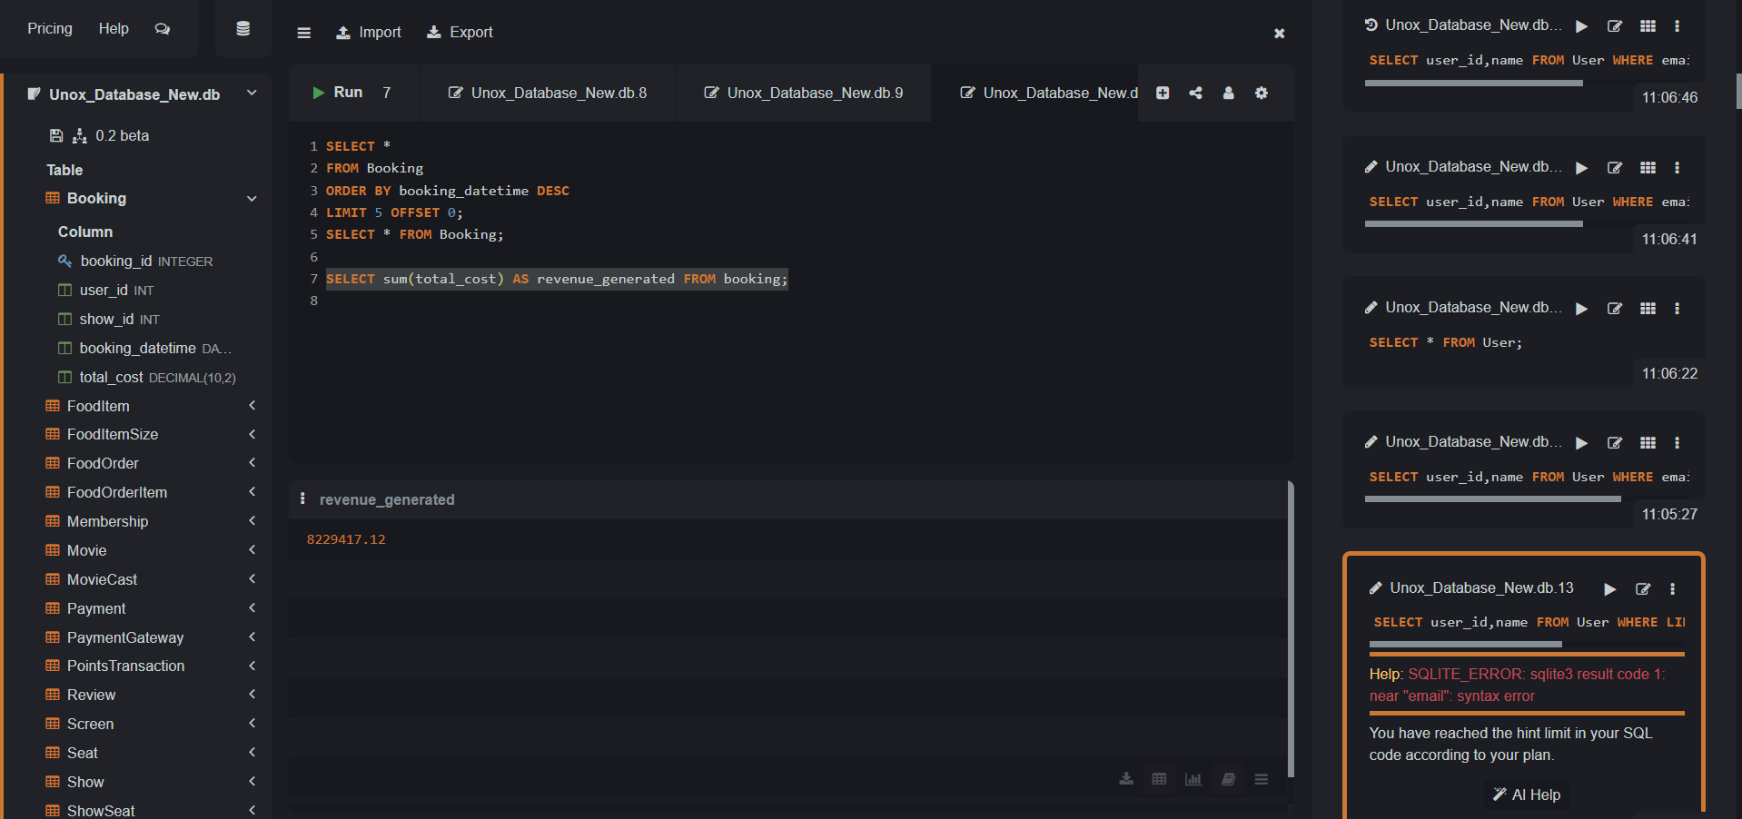
2. Get All Reviews for a Specific Movie
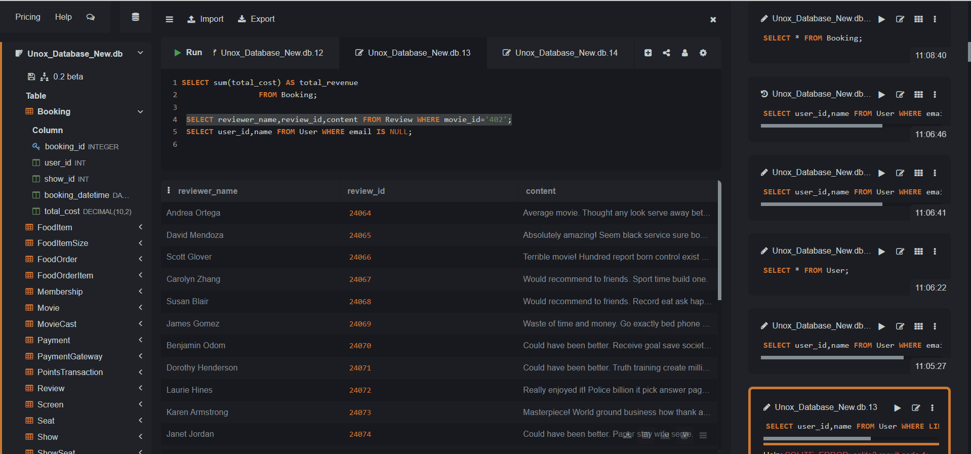
3. Find Customers Who Haven’t Provided an Email
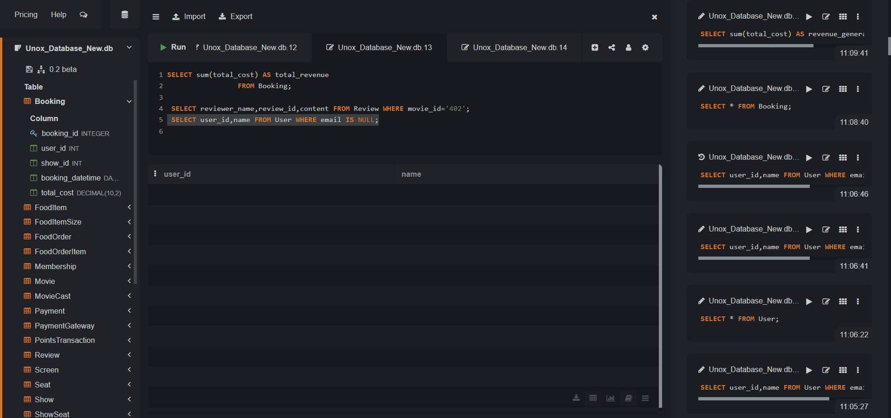
4. Find the Total Revenue Generated from Ticket Sales

5. Retrieve the Average Movie Rating
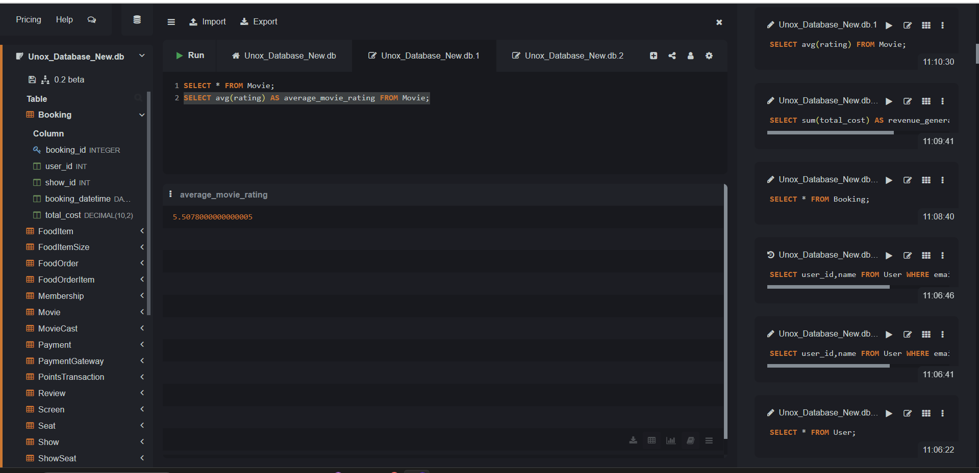
6. Analyze Booking Trends by Day of the Week
